**INNOVATIVE GREEN TECHNOLOGIES**

Innovative green technologies represent the cutting edge of environmental sustainability, offering solutions to mitigate climate change, reduce pollution, and conserve natural resources. These technologies span various sectors, from energy production to transportation, agriculture, and construction. In this exploration, we'll delve into some of the most promising green technologies, highlighting their potential impact and the challenges they aim to address.

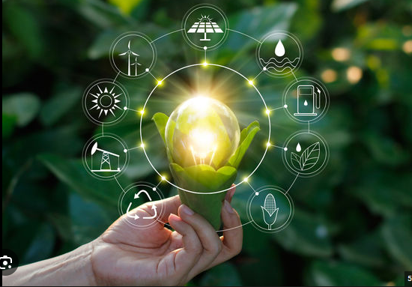

* **Solar Energy:**  
  Solar power stands as one of the most abundant and accessible sources of renewable energy. Advances in photovoltaic (PV) technology have led to more efficient solar panels, lowering costs and expanding deployment. Additionally, innovations like solar paint, which converts any surface into a solar panel, and concentrated solar power (CSP), which uses mirrors to focus sunlight onto a small area for electricity generation, are pushing the boundaries of solar energy utilization.
* **Wind Energy:**Harnessing the power of wind through wind turbines has become increasingly widespread. Offshore wind farms, in particular, offer vast potential for clean energy generation without occupying valuable land resources. Improved turbine design, such as taller towers and larger rotor blades, enhances efficiency and reduces the cost of wind energy production.
* **Energy Storage:**Energy storage technologies play a crucial role in enabling the integration of intermittent renewable energy sources like solar and wind into the grid. Lithium-ion batteries, as well as emerging technologies like flow batteries, compressed air energy storage (CAES), and pumped hydro storage, provide options for storing excess energy and delivering it when needed, thereby enhancing grid stability and reliability.
* **Electric Vehicles (EVs):**The transportation sector is a significant contributor to greenhouse gas emissions, making the transition to electric vehicles imperative. Advances in battery technology have extended the range and reduced the cost of EVs, making them increasingly competitive with traditional internal combustion engine vehicles. Moreover, developments in charging infrastructure, including fast-charging stations and wireless charging technology, are addressing concerns about range anxiety and accessibility.
* **Smart Grids:**  
  Smart grid systems leverage digital technologies to optimize energy distribution, enhance grid resilience, and accommodate the growing share of renewable energy sources. Through real-time monitoring, data analytics, and demand-response mechanisms, smart grids enable more efficient energy management, reducing waste and carbon emissions while supporting the integration of distributed energy resources like rooftop solar panels and electric vehicles.
* **Sustainable Agriculture:**Innovations in agriculture aim to increase food production while minimizing environmental impact. Vertical farming, aquaponics, and hydroponics enable efficient cultivation in urban areas, reducing the need for land, water, and pesticides. Additionally, precision agriculture techniques, such as GPS-guided tractors and drones equipped with sensors, optimize resource utilization and crop yields while minimizing inputs.
* **Green Building Materials:**The construction industry is embracing eco-friendly building materials that reduce energy consumption, improve indoor air quality, and minimize waste. These materials include recycled steel, bamboo, straw bales, and low-emission insulation. Furthermore, advancements in energy-efficient building design, such as passive solar heating, natural ventilation, and green roofs, contribute to sustainable development and mitigate the urban heat island effect.
* **Waste-to-Energy Conversion:**Converting waste into energy not only reduces landfill volumes but also generates renewable electricity or heat. Technologies like anaerobic digestion, gasification, and pyrolysis enable the efficient conversion of organic waste, biomass, and municipal solid waste into biogas, syngas, or biochar. These bioenergy sources can displace fossil fuels, mitigate greenhouse gas emissions, and contribute to a circular economy.
* **Water Purification and Desalination**:  
  As water scarcity becomes increasingly prevalent, innovative technologies for water purification and desalination are critical for ensuring access to clean water. Membrane filtration, reverse osmosis, and solar-powered desalination systems offer sustainable solutions for treating brackish water, seawater, and wastewater, thereby addressing water scarcity challenges and promoting water reuse.
* **Carbon Capture and Utilization (CCU):**   
  Carbon capture and utilization technologies capture carbon dioxide emissions from industrial processes and convert them into valuable products, such as synthetic fuels, chemicals, or building materials. By turning a greenhouse gas into a resource, CCU not only helps mitigate climate change but also creates economic opportunities for industries to transition to a low-carbon future.   
    
   **conclusion**

Innovative green technologies hold immense potential to transform industries, mitigate environmental degradation, and foster sustainable development. However, realizing this potential requires concerted efforts from governments, industries, researchers, and society as a whole to overcome technical, economic, and regulatory barriers. By embracing these technologies and fostering innovation, we can pave the way for a more sustainable and resilient future for generations to come.